EnSuperoxide dismutase (SOD) is an antioxidant enzyme produced in our bodies to neutralize a specific oxygen-derived free radical called superoxide.

Oxygen that we breathe in is a source of life, but at the same time it can cause damage in the body by creating oxygen free radicals, molecules that become unstable by losing or gaining an electron and have to balance themselves by stealing electrons from other molecules, creating a chain reaction.
Superoxide dismutase (SOD) is an enzyme that catalyzes the dismutation (or partitioning) of the superoxide (O₂⁻) radical into either ordinary molecular oxygen (O₂) or hydrogen peroxide (H₂O₂). The O₂⁻ radical is produced as a by-product of oxygen metabolism and, if not scavenged, causes many types of cell damage. SOD is an important oxidant defense in nearly all living cells exposed to oxygen.
These oxygen-derived free radicals, also known as reactive oxygen species (ROS), indiscriminately attack vital molecules, such as proteins, carbohydrates, and fats, which are a part of every single cell in our bodies, both inside and outside the cells, changing their function and impairing the normal course of metabolism in cells. ROS are also capable of damaging DNA. When enough cells get affected this way, disease sets in.
In healthy people any damage from ROS is successfully counteracted with sufficient antioxidants that are either produced in the body or consumed with food – cells have developed these complex ways of controlling ROS but they are never completely eliminated. If this balance is tipped in favor of free radicals, oxidative stress occurs.
Among the free radicals, superoxide (an oxygen molecule with an extra electron) is the most dangerous with a potential for much damage. This is because each superoxide molecule requires not one but three electrons to rebalance itself, and it does so more rapidly than regular free radicals that miss an electron rather than gain an extra one.
1%-3% of all oxygen consumed by our bodies is transformed into superoxide. And it is estimated that we produce around 3 tons of superoxides over our lifetime. But no matter the source of superoxides, the good news is that all our cells produce superoxide dismutase to neutralize these superoxide free radicals.
A mutase is a type of enzyme that helps transform two molecules simultaneously in similar but opposite reactions by initiating the rearrangement of their atoms.
One SOD molecule takes two superoxide molecules (let’s call them A and B), removes the extra electron off superoxide A, and places it on the superoxide B. As a result, superoxide A loses the extra electron and returns to being a normal oxygen molecule. Superoxide B ends up with two extra electrons, attracts two hydrogen ions and becomes hydrogen peroxide, a less harmful ROS. Hydrogen peroxide is further reduced to oxygen and water by enzymes catalase (CAT) and glutathione peroxidase (GPx). Below is the simplified representation of this complex process:

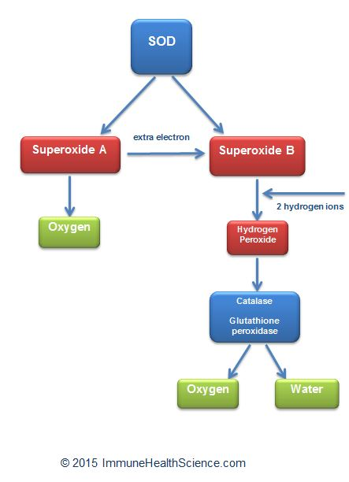

In humans, SOD exists in three forms and functions in various locations throughout the body:
- SOD1 or CuZnSOD – intracellular SOD, requires copper (Cu) and zinc (Zn) to perform its function and protects the cell’s cytoplasm, the substances enclosed by the cell’s membrane where most of the cellular activity occurs.
- SOD2 or MnSOD – intracellular SOD, requires manganese (Mn) to perform its function and protects the cell’s mitochondria.
- SOD3 or EC-SOD– extracellular SOD, also requires copper and zinc and acts outside the cells.
Availability of superoxide dismutase is crucial for maintaining redox balance in the body. For example, mice genetically engineered to lack the SOD2 gene, that regulates the production of MnSOD, die of overwhelming oxidative stress within 10 days of birth. (Dilated cardiomyopathy and neonatal lethality in mutant mice lacking manganese superoxide dismutase. Li Y, Huang TT et al. Nat Genet. 1995 Dec;11(4):376-81).
Mice without the ability to produce CuZnSOD showed no apparent abnormalities up until early adulthood but had shorter lifespan and more than 70% of them developed liver cancers later in life. (CuZnSOD deficiency leads to persistent and widespread oxidative damage and hepatocarcinogenesis later in life. Elchuri S, Oberley TD etal. Oncogene. 2005 Jan 13;24(3):367-80).
Low SOD levels are characteristic of some debilitating diseases and health: HIV/AIDS, asthma, burns, all cancers, cataracts, chronic fatigue syndrome, diabetes, autoimmune disorders, diseases of liver, kidneys, lungs, heart and digestive system, fibromyalgia, multiple sclerosis, Parkinson’s, Alzheimer’s, ALS (Lou Gehrig’s), neuropathies, physical traumas, skin disorders, seizures, tumors, chronic inflammation, recurring infections, susceptibility to colds and flus.
If left unchecked, superoxide radicals break DNA strands, Adequate SOD levels effectively neutralize superoxides and undoubtedly contribute to maintain health

